Title of the Working Research Paper (Times New Roman 14, bold, center)

Name of the author(s) (Times New Roman 12, bold, center)

Abstract (maximum 250 words)
Abstract (6-12 lines, Times New Roman 12, italic, block-aligned), abstract (6-12 lines, Times New Roman 12, italic, block-aligned), abstract (6-12 lines, Times New Roman 12, italic, block-aligned), abstract (6-12 lines, Times New Roman 12, italic, block-aligned).

JEL classification: three JEL codes maximum; example: E 44, J 30 etc.
Keywords: three, keywords, maximum; example: economic growth, interest rate etc.

1 Introduction The titles of the main chapters 1 - 6 are obligatory!
Normal text of the paper (Times New Roman 12, block-aligned, first line in the paragraph has 0.63 cm indent, single line spacing, spacing 6 pt after paragraph).
2 Current State of the Solved Problem at Home and Abroad
Normal text of the paper (Times New Roman 12, block-aligned, first line in the paragraph has 0.63 cm indent, single line spacing, spacing 6 pt after paragraph).
Normal text of the paper (Times New Roman 12, block-aligned, first line in the paragraph has 0.63 cm indent, single line spacing, spacing 6 pt after paragraph).
3 Research Design or The Aim of the Paper, Research Methodology and Methods
Normal text of the paper (Times New Roman 12, block-aligned, first line in the paragraph has 0.63 cm indent, single line spacing, spacing 6 pt after paragraph).
(The Hypothesis ; Basic Research Aim ; Partial Research Goals ; Object of the Research; Methodology and Methods of the Research ; Model and Data or Objectives and methods of research, research sample)
Normal text of the paper (Times New Roman 12, block-aligned, first line in the paragraph has 0.63 cm indent, single line spacing, spacing 6 pt after paragraph.)
4 Result of the Paper, (or Research Results) or Result of the Paper (or Research Results) and Discussion
Normal text of the paper (Times New Roman 12, block-aligned, first line in the paragraph has 0.63 cm indent, single line spacing, spacing 6 pt after paragraph).
Normal text of the paper (Times New Roman 12, block-aligned, first line in the paragraph has 0.63 cm indent, single line spacing, spacing 6 pt after paragraph).
5 Discussion or Discussion and Conclusion
Normal text of the paper (Times New Roman 12, block-aligned, first line in the paragraph has 0.63 cm indent, single line spacing, spacing 6 pt after paragraph.).
Normal text of the paper (Times New Roman 12, block-aligned, first line in the paragraph has 0.63 cm indent, single line spacing, spacing 6 pt after paragraph).
6 Conclusion or Conclusions and Recommendations
Normal text of the paper (Times New Roman 12, block-aligned, first line in the paragraph has 0.63 cm indent, single line spacing, spacing 6 pt after paragraph).
Normal text of the paper (Times New Roman 12, block-aligned, first line in the paragraph has 0.63 cm indent, single line spacing, spacing 6 pt after paragraph).

Acknowledgement

Of your choise, write for example: The article is an (partial) output of research project VEGA MŠ SR a SAV No. VEGA 1/0000/15 entitled ….. or This contribution is the result of the project VEGA (5/1234/12) Perspectives of the asdf asdf asdf etc.

References

Make the list of references in alphabetical order. The list of references must contain only items cited in the text.

Citation of a book, ISBN (you are required to indicate the ISBN)
Tyler, T. R. (1990). Why People Obey the Law. New Haven: Yale University Press, 1990. ISBN 978-80-12451-5.

Citation of a book chapter
McCarty, T. – Yaisawarng, S. (1993). Technical Efficiency in New Jersey School Districts. In Fried, H.O. et al. (eds.) The Measurement of Productive Efficiency: Techniques and Applications. Oxford: Oxford University Press, pp. 98–120. ISBN 123-12456-2-12.

Citation of a journal paper, ISSN (you are required to indicate the ISSN)
Carter, M. (1984). Issues in the Hidden Economy. Economic Record. Vol. 60, Issue 5, pp. 209-2011. ISSN 1234-5678.

Citation of a working paper
Tanzi, V. & Shome, P. (1993). A Primer on Tax Evasion. IMF Staff Papers, 40, 807-825. Washington D.C.: International Monetary Fund. DOI 10.1000/9780110002224.

Citation of a paper published in conference proceedings
Stavárek, D. (2004). An Empirical Investigation of the Relations Between Stock Prices and Exchange Rates. In Proceedings of the Third International Symposium on Business Administration. Gelibolu, Çanakale: Çanakale Onsekiz Mart University, pp. 793–811. ISBN 123-45678-12-4.

Citation from an internet resource
World Bank. (2005). Private Participation in Infrastructure Project Database. http://ppi.worldbank.org/reports/customQueryAggregate.asp, [accessed 7.1.2020].

Contact

Author's name
University of Economics in Bratislava
Faculty of Business Management
Department of
Dolnozemská cesta 1/b
852 35 Bratislava
Slovak republic
e-mail: @
Author's share XX%

Author's name
University of Economics in Bratislava
Faculty of Business Management
Department of
Dolnozemská cesta 1/b
852 35 Bratislava
Slovak republic
e-mail: @
Author's share XX%

A) Instructions - text formatting, tables and figures, equations and formulas, bibliographic citations

1 Introduction (First-level heading, Times New Roman 12, bold)
Normal text of the paper (Times New Roman 12, block-aligned, first line in the paragraph has 0.63 cm indent, single line spacing, spacing 6 pt after paragraph), normal text of the paper (Times New Roman 12, block-aligned, first line in the paragraph has 0.63 cm indent, single line spacing, spacing 6 pt after paragraph), normal text of the paper (Times New Roman 12, block-aligned, first line in the paragraph has 0.63 cm indent, single line spacing, spacing 6 pt after paragraph).
Normal text of the paper (Times New Roman 12, block-aligned, first line in the paragraph has 0.63 cm indent, single line spacing, spacing 6 pt after paragraph), normal text of the paper (Times New Roman 12, block-aligned, first line in the paragraph has 0.63 cm indent, single line spacing, spacing 6 pt after paragraph), normal text of the paper (Times New Roman 12, block-aligned, first line in the paragraph has 0.63 cm indent, single line spacing, spacing 6 pt after paragraph).
1.1 Model and Data (Second-level heading, Times New Roman 12, bold, italic)
Normal text of the paper (Times New Roman 12, block-aligned, first line in the paragraph has 0.63 cm indent, single line spacing, spacing 6 pt after paragraph), normal text of the paper (Times New Roman 12, block-aligned, first line in the paragraph has 0.63 cm indent, single line spacing, spacing 6 pt after paragraph).
1.1.1 Model Calibration (Third-level heading, Times New Roman 11, italic)
Normal text of the paper (Times New Roman 12, block-aligned, first line in the paragraph has 0.63 cm indent, single line spacing, spacing 6 pt after paragraph), normal text of the paper (Times New Roman 12, block-aligned, first line in the paragraph has 0.63 cm indent, single line spacing, spacing 6 pt after paragraph).
B) Format Guidelines
Tables and figures should be numbered and references to them must be in the text. Acceptable labeling for a table is Table 1 and Figure 1 for a figure. The title of the table or figure is placed above and the source below the table or figure. The text should be composed in such a manner that there are not a greater number figures or tables on a single page. Tables and figures in landscape format are not acceptable.

Table 1
Title of the Table (Times New Roman, 12, left-aligned)
 | 2016 | 2017 | 2018 | 2019 | 2020
Poland
Russia
Sweden
Source: please provide a source website, paper, author’s calculations, etc.
Notes: normal text of notes, spacing 6 pt after paragraph
Normal text of the paper (Times New Roman 12, block-aligned, first line in the paragraph has 0.63 cm indent, single line spacing, spacing 6 pt after paragraph). Normal text of the paper (Times New Roman 12, block-aligned, first line in the paragraph has 0.63 cm indent.

Figure 1
Title of the Figure (Times New Roman, 12, left-aligned)
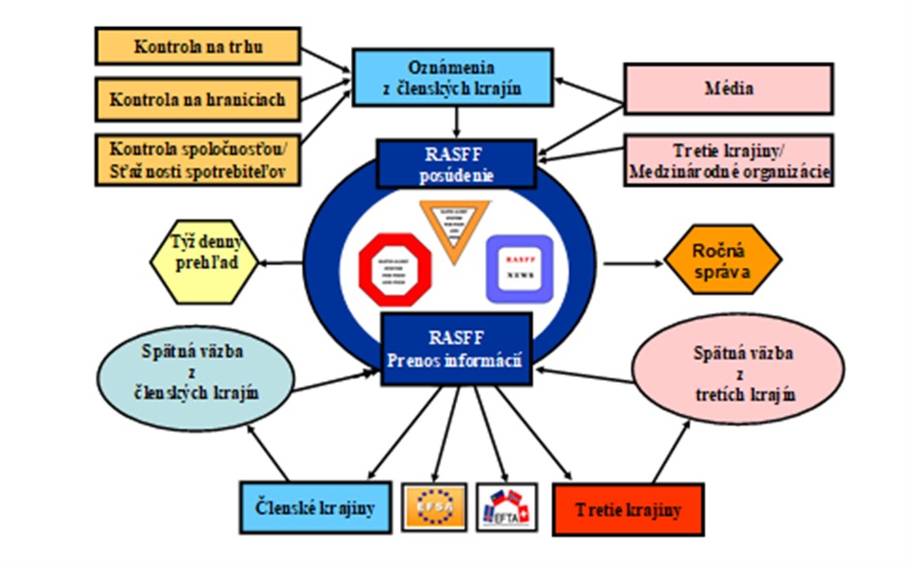
Source: please provide a source website, paper, author’s calculations, etc.
Notes: normal text of notes, spacing 6 pt after paragraph
Equations and formulas are denoted by numbers in round parentheses and it is recommended to be produced by Editor of equations or inserted by the jpg format.
(1)
(2)
(3)
(4)
λ_{j} ≥ 0, j = 1,2,…,n (5)
Bibliographic citation must be in accordance to examples provided below. The list of references should be complete and accurate. For each work shown in the list of references must be a reference in the text. Citation in the text must be according to following rules:
- 1 author
  - Clotfelter’s (1983) empirical study ...
  - ... they are not reported at all (Macafee, 1980; Tanzi, 1980).
- 2 authors
  - ... and Alm, Bahl and Murray (1993) find, …
  - … hypothetical questions about their behavior (e.g. Park & Hyun, 2003) …
- 3 and more authors: cite only the first name followed by et al.
  - ... is the recent study by Andreoni et al. (1998).
  - … hypothetical questions about their behavior (Alm et al., 1992) …
Normal text of the paper (Times New Roman 12, block-aligned, first line in the paragraph has 0.63 cm indent, single line spacing, spacing 6 pt after paragraph). Normal text of the paper (Times New Roman 12, block-aligned, first line in the paragraph has 0.63 cm indent.
C) Conclusions and policy implications
Normal text of the paper (Times New Roman 12, block-aligned, first line in the paragraph has 0.63 cm indent, single line spacing, spacing 6 pt after paragraph). Normal text of the paper (Times New Roman 12, block-aligned, first line in the paragraph has 0.63 cm indent, line spacing, spacing 6 pt after paragraph).

